PagerDuty Integration

A. PagerDuty + HEAL Integration Benefits (on HEAL Website)
Sample shared by PagerDuty: https://docs.thundra.io/thundra-web-console/profile/settings-page/pagerduty-tab/pagerduty-+-thundra-integration-benefits

Benefits of PagerDuty Integration
- Notifies on-call operations team members whenever an anomaly is detected and an Early Warning or Problem Signal is generated by HEAL
- Creates an Incident ticket with details about the application, component and problem metrics
- Provides a permalink to the HEAL Signals page for accessing the Root-Cause Analysis, Forensic deep-dive into the problem and related Early Warnings or Problem signals

How it works
HEAL generates an Early Warning or Problem Signal when it notices abnormal application behavior before end-users are impacted. This Signal triggers an incident and alert in PagerDuty through the integrated PagerDuty plugin.

Requirements
PagerDuty integration requires installing the PagerDuty plugin on the HEAL Server and configuring the plugin to connect to the PagerDuty instance. You need to have a PagerDuty account for the integration to work.

Support
If you need any help to complete the PagerDuty integration, you can connect with us at support@appnomic.com.

Integration Walkthrough

In PagerDuty
HEAL is integrated using PagerDuty’s Events API v2. This integration requires an existing PagerDuty Service to be configured. If this Service is already configured in PagerDuty, go to section “Configuring Existing Service”. Otherwise, follow the steps below to create a new Service.

Creating New Service
- To create a new Service, refer to the PagerDuty documentation here. Select the option “Use our API directly” while creating the Service.
- On the Service page click on Integrations and copy the Integration Key to be used later.
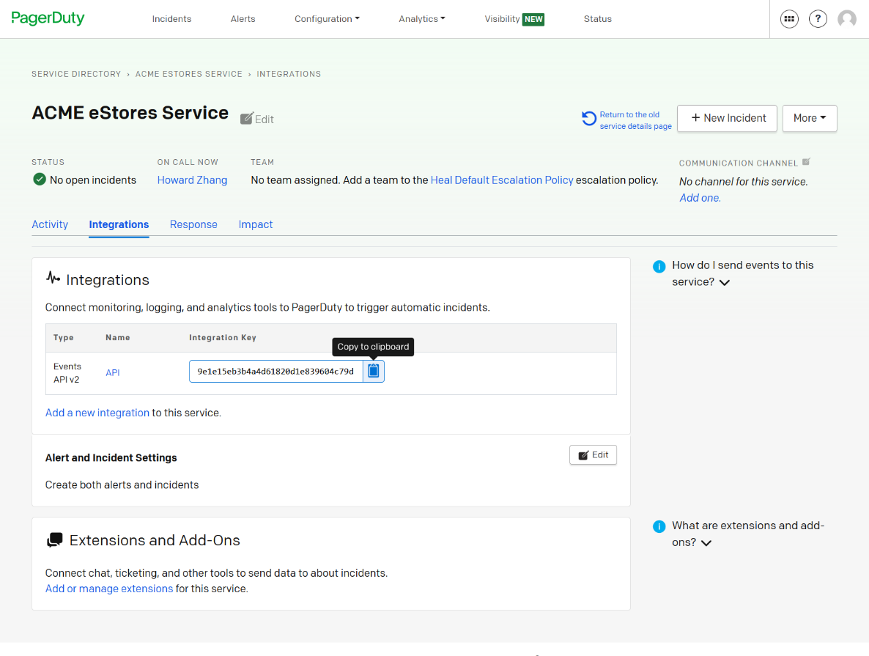

Configuring Existing Service
- Go to the Service page
- Click on Integrations.
- If an Events API v2 integration exists, copy the Integration Key to be used later.
- If an Events API v2 integration does not exist:
  - Follow the PagerDuty documentation here to add an integration. Select the option Use our API directly while creating the Integration
  - Copy the Integration Key to be used later.

In the HEAL Server
Add the Integration Key obtained from PagerDuty, as explained above, to the PagerDuty Plugin configuration.
- Navigate to <install directory>/Appsone_service/a1eventhandler/config folder
- Edit the file plugin-details.json to enter the Integration Key in the “PagerDuty_Integration_Key” field
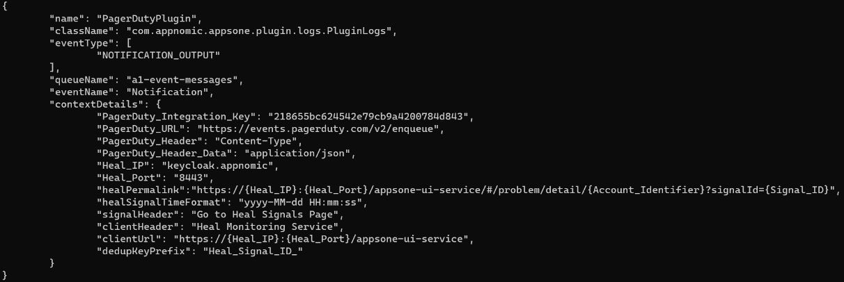
- Save the file and restart the HEAL Event Handler service for the changes to take effect.
As soon as this is done, the PagerDuty plugin should start sending events to PagerDuty so that incidents get created. This would indicate a successful deployment of the PagerDuty plugin.
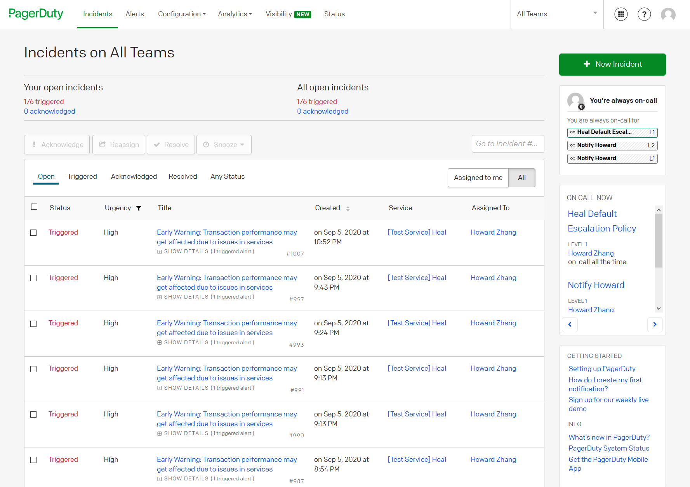

How to Uninstall
To stop HEAL from creating incident tickets and alerts in PagerDuty, remove the PagerDuty plugin from the HEAL Server.
- Stop the HEAL Event Handler service
- Delete the PagerDuty Plugin from the <plugin> directory
- Start the HEAL Event Handler service

B. Integrations Page (on PagerDuty website)
Sample shared by PagerDuty: https://www.pagerduty.com/integrations/demisto/

 | Autonomous IT Operations for a Self-healing Enterprise
In a fast-paced world where every second counts, it’s no longer good enough to detect and flag incidents after they happen. HEAL is a preventive healing solution that predicts and eliminates factors that cause problems and outages. HEAL is a paradigm changing solution that uses AI algorithms and machine learning models to help enterprises run without a hitch.

Using a patented technique called ‘workload-behavior correlation’, HEAL analyzes all aspects required to run IT systems without incident (the cumulative volume, composition and payload), and reacts every time an abnormal behavior occurs, triggering a notification through PagerDuty and also healing or scaling actions depending on the root cause of the problem.

 | Learn about HEAL’s Integration with PagerDuty
<This button links to the PagerDuty + HEAL Integration benefits page>

PagerDuty and HEAL Integration
Event Intelligence | Situational Awareness | Autonomous Healing
Leverage PagerDuty’s Event Intelligence to identify incident patterns and human responses to resolve incidents. Build autonomous healing workflows for repeating patterns and move towards becoming a self-healing enterprise. | Incidents created in PagerDuty contain detailed contextual information about applications, services, violated KPIs and a permalink to the HEAL Signal for forensics, deep-dive and detailed root-cause analysis. | HEAL enables autonomous healing of repeating problems. In scenarios where autonomous healing is configured, the incident ticket is resolved as soon as the healing completes successfully requiring no human intervention.

About HEAL
HEAL is the industry’s first preventive healing software for IT Operations that eliminates incidents and problems before they occur, so you can focus your energy on what really matters.
Learn more

(Link to: https://appnomic.com/products/heal/)

Resources

SOLUTION BRIEF |  | CASE STUDIES |  | SIGN-UP
PagerDuty and HEAL Solution Brief. An overview of the PagerDuty and HEAL Integration.  <Solution brief doc yet to be prepared> |  | Top use-cases where customers have saved downtime and resources due to early-warnings and precise RCA generated by HEAL |  | Sign-up for a HEAL demo or talk to our Solutions team.

